Parent University ADHD
WHEN: FEBRUARY 6, 2019 PRESENTATION IS FROM 6-7
WHERE: NEW ADMINISTRATION BUILDING (AKA OLD KINDERGARTEN BUILDING)
DINNER PROVIDED AT 5:30
RSVP: MARTHA GRAY MGRAY@PREMIERCHARTERSCHOOL.ORG

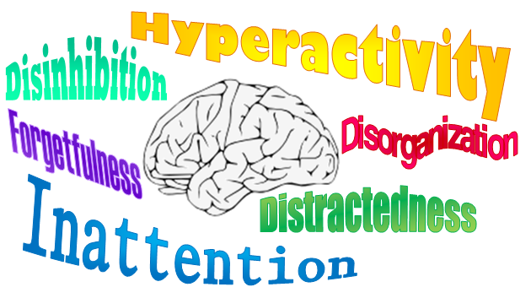

Does your child, you or someone you know and love have an ADHD diagnosis? Do you suspect a diagnoses? Please come join us for this panel discussion. We will have an Administrator/ parent, a student, a Chiropractor, an Occupational Therapist, a Nutritionist and a Licensed Therapist on the panel to help guide through any questions and resources we may have about ADHD. We’d also love to hear from you on what works for you and what concerns you have. We all know how AMAZING kids are with an ADHD diagnoses but there can be challenges...come chat with us!

