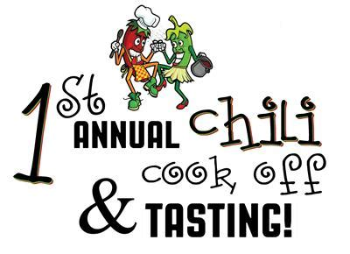

PLEASE JOIN US IN OUR 1ST CHILI COOKOFF AT PCS!
CHILI COOKOFF WILL TAKE PLACE DURING
TRUNK OR TREAT
ONLY $5 TO TASTE AND VOTE FOR YOUR FAVORITE CHILI!
Individual bowls will be for sale - $1
WINNER GETS BRAGGING RIGHTS & A PRIZE!
*Must be in attendance at Trunk or Treat to participate*
SIGN UP BELOW TO ENTER YOUR POT OF SPECIALTY CHILI IN THE CONTEST!

COOK’S NAME/PHONE #: ___________________________
CHILDS NAME/GRADE: _____________________________
Questions, contact Nancy 314-580-4298 or Maggie 314-305-3131)

